Assignment 5

# question 1

PP4.1 on p. 202. The Counter class has no setter and toString methods. The CounterTest class is posted on Acorn. Submit both Counter.java and CounterTest.java

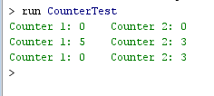

# question 2

PP4.3 on p. 202. Use Math.PI and Math.pow in the volume/area formulas. There is only one instance variable. The formula for volume should only be coded once. Similarly for area. MultiSphere is posted on Acorn. Submit both Sphere.java and MultiSphere.java

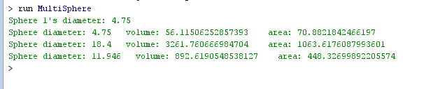

# question 3

PP4.6 on p. 203. Only 4 instance variables allowed. The instance variable full is of type boolean, the others are int’s. Name the getter method for full isFull instead of getFull. There is a typo in the text. Method toString returns a single String which contains 2 lines of text. BoxTest is provided on Acorn. Submit both Box.java and BoxTest.java

